**Here we are discussing How to simulate client invoked Service calls.**

Step1:Login to Tosca cloud & download the SIM Agent

Step2: Execute the agent (Tricentis.Simulator.Agent) which open the SIM agent in browser. Authenticate . Connect SIM agent with your Tosca cloud providing your workpace URL

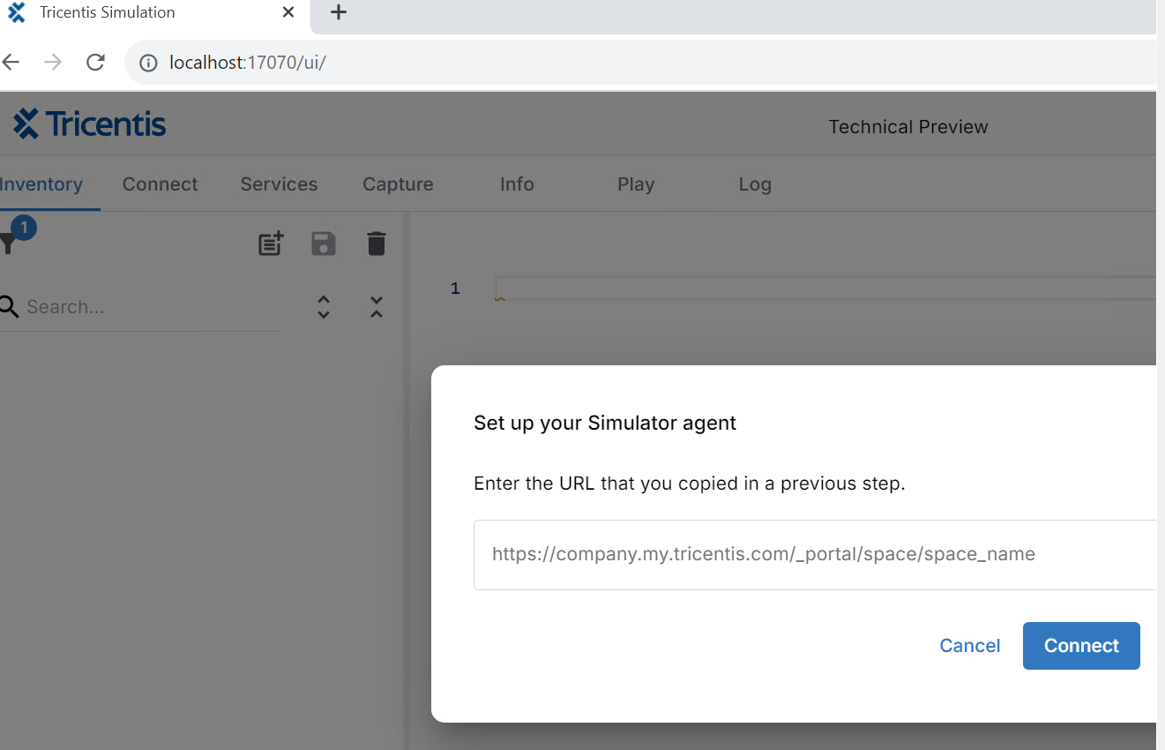

Step3:From inventory upload yaml file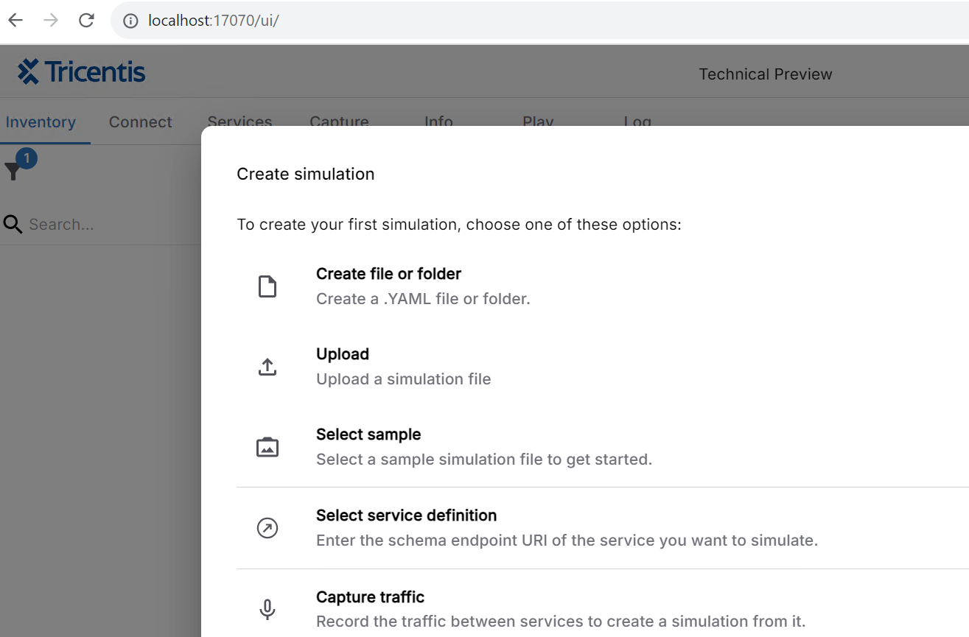

You can find the simulating API’s payloads

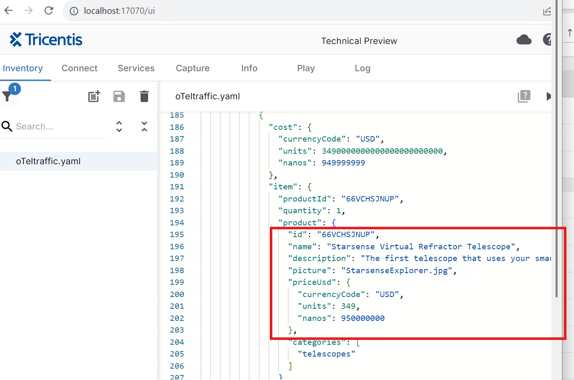

Step4: Open oTel Neoload project. You can find the simulation server details which we started locally.

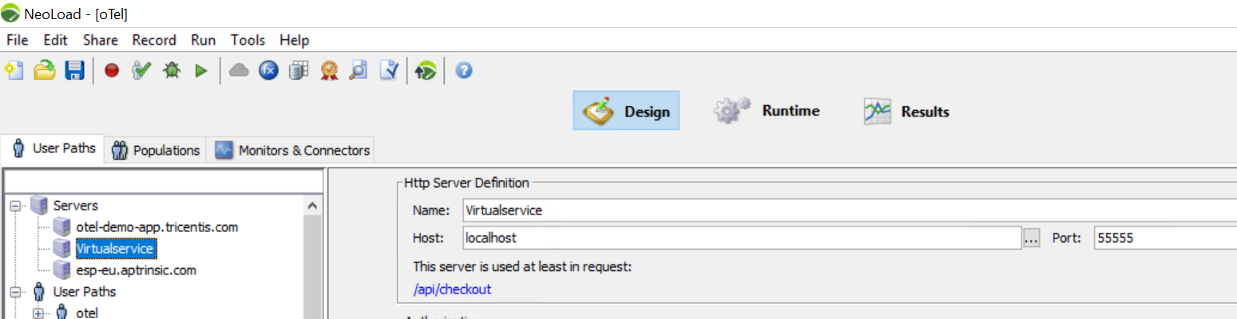

Go to place order transaction point the expensive checkoutAPI to Local simulator

Step5:Validate User path . In real word you can extract value from response & use in the subsequent API call

